(This manual was updated on 8/19/2026. By Dr. Beznosko and Dr. Krivosheev)

Lab 10: Energy Conservation
By: Dr. D. Beznosko, A, Iakovlev
(Lab outcomes: a plot with multiple data series, analysis using a plot of residuals.)

Abstract
Energy Conservation is a Tracker-based assignment. The moving body experiences various forces that do the work on the body that alters its total mechanical energy. Using Tracker, the potential and kinetic energy of the body on the spring will be tracked and analyzed to get familiar with the energy approach concept.

Introduction
The energy approach to analyzing body motion is the most important in modern physics (note: momentum normally is also included). This approach was started by Hamilton and Lagrange some years back – a good place to begin your introduction and add a few words on Lagrangian and Hamiltonian mechanics? Do some research as it’s a very interesting topic beyond the lecture material. Remember to include the references!

Experimental Setup
For this experiment, use the high frame rate video provided. You could consider making your own video using lab equipment if you have a high-speed camera (at least 480 fps). Discuss this option with instructor if interested.
The setup schematic is outlined in Figure 1 and consists of the ruler (Figure 1a) to set the scale, the spring (Figure 1b) and the attached body (Figure 1c). Do not copy this schematic. Consider describing the setup using the screenshot instead (as in Figure 2).
Ruler
c)
b)
a)
body

Figure 1: The experimental setup schematic for shooting the video. (a) ruler used to set the scale, (b) a spring, (c) the attached body.
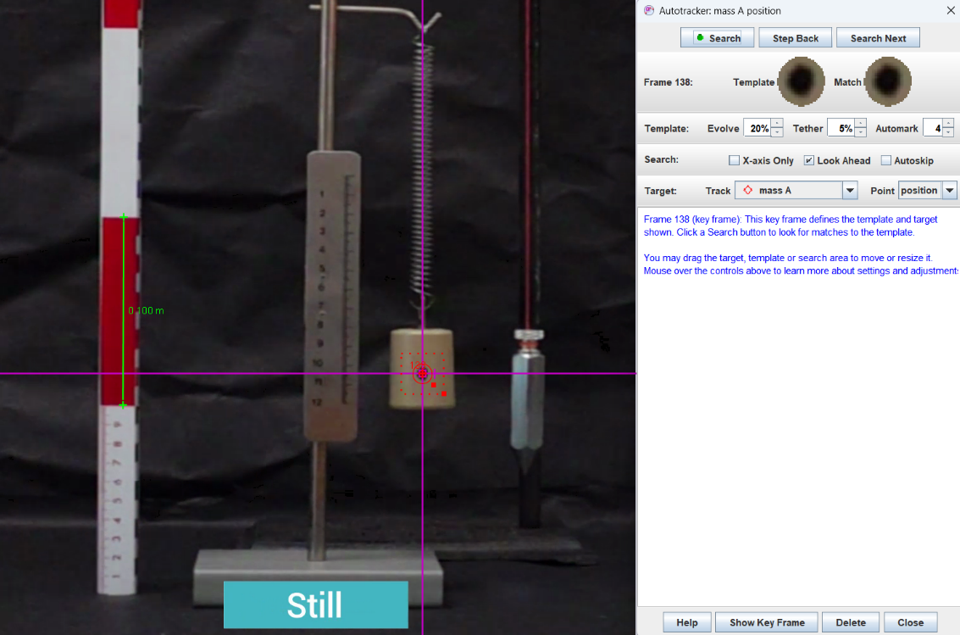
Figure 2: Tracker screen setup. The scale, axes, and the object template are set.

Procedure:
Download the video provided and open it in Tracker. Make sure you unzip it if needed.
Set the scale using the ruler and set the axes making sure that the vertical axis matches the string with a bob serving as an indicator. The center of coordinates must be where the colored dot on the body is before it starts moving. Look for the frames that are marked “Still” in the video!
From Figure 3 obtain the object mass and write it down with error (the digits don’t change on the scale, so what will be the error of this measurement? The mass is in grams – convert to kg.).
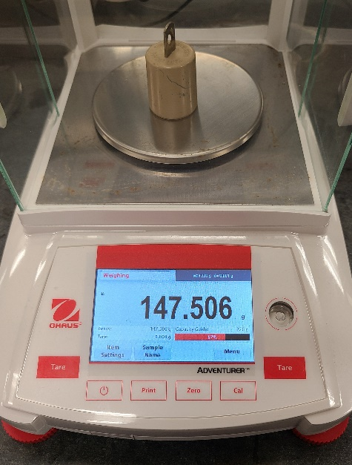
Figure 3. Weight of the mass attached to the spring
Create the tracking template using the colored dot on the body. Do the tracking from the very start of the video and include at least several full oscillations of the spring. The Tracker should display the $y vs t$ and $v_{y} vs t$ plots.
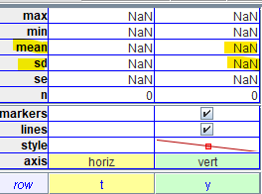
First, right-click on the $v_{y} vs t$ plot and choose ‘Analyze’, so that it now is displayed in the analysis window. Don’t close the analysis window! Now go back to the Tracker main window and use the $y vs t$ plot for further analysis – that is, right click on it and choose ‘Analyze’. Two plots are now displayed with the $y vs t$ plot as active.
First, enable the ‘Analyze button – statistics’ option and select several tens of the points from the horizontal part of the plot indicating that the body was not moving (Figure 4a). The stdev (named sd in Tracker) of these points is the statistical error in position determination. If the stdev value is smaller than the mean, you may need to better align the center of the coordinates with the center of the colored dot and see how the values update (the update should happen automatically – if not, select the points again. Re-doing tracking is not needed.).
Hint: You can manipulate axes with arrow keys on your keyboard after you click on the center point of the axes with your mouse. This allows for very fine control of the position.
The average (mean) of these points should be very close to 0, with the value smaller than the stdev (sd). For even finer adjustments, you can also zoom in! Write down the mean value of $y$ and the sd after all the adjustments are complete. Don’t close the analysis window!
Delete and create the calibration stick four more times. The value of the mean for the $y$ will change. Find the stdev for all five values of $y$. These are systematic errors. Combine the errors in quadrature. This is the total error for a vertical position. We will use it for the final plot.
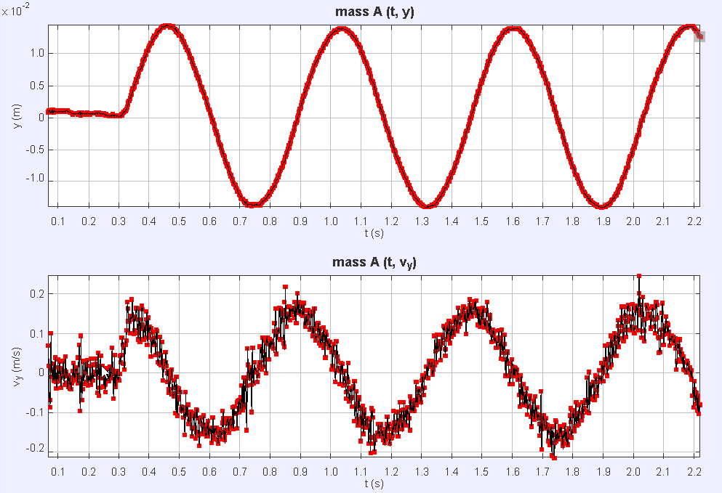
a
Figure 4. $y vs t$ and $v_{y} vs t$ plots, (a) points for calculation of the statistical error for position
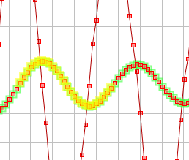
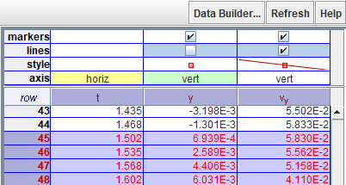
Select one full oscillation using the $y vs t$ plot. One full oscillation is when $y$ varies from 0, the moves to a positive maximum, back to 0, to negative maximum and back to 0 (if you have few extra points on both or either side – that’s ok). Or to negative first and positive second, it doesn’t matter. In the table with data, you should see the cells that got highlighted. Note that only t and y cells are selected but we also need the $v_{y}$. Hold the <Shift> key and click on the top of the $v_{y}$ column, on the place where it is written “$v_{y}$” as indicated by the red arrow! This should add to the selection of the cells for the velocity that match the ones selected for the position. Copy the data to Excel or other spreadsheet software you use (you can use the template provided, see the analysis section for details). Hint: There are two ways to copy. One is right click on the highlighted cells, choose ‘Copy contents -> As formatted’. Second: you can copy from the Tracker directly using <Ctrl>+<c>. Save the file and keep this data for further analysis. Close the Tracker.

As we are using a spring, before proceeding further, we need to know $k$, the spring constant.
For this, you have the following options:
For PHYS 1111L only:
Download the provided data file from D2L “Lab 10 - Energy conservation - Spring constant data - ALL data.xlsx”. The file contains 6 different runs where a PASCO Smart Cart is pulled manually (Figure 5) to stretch the spring from setup in Figure 2. Force and position data were recorded. You will use it to find the spring constant. Plot all runs and fit with a line. Find the error on each slope using linear regression. The average of these errors is statistical error. The stdev of all the slopes themselves is the systematic. Combine two errors in quadrature. Take the average of these slopes. This is your spring constant and its error. Units! Show some steps.
For PHYS 2211L (PHYS1111L will get extra points for following these steps instead).
Download the six provided data files from D2L. Their names are “Lab 10 - Energy conservation - Spring constant data RUN 1.csv” and all the way to “Lab 10 - Energy conservation - Spring constant data RUN 6.csv”.
Open a new Tracker instance (don’t use the one where you analyzed the video). Import the data using the skills from lab 8. In the analysis window, plot the $Force vs Position$, fit it with the line and find the spring constant $k$ as the slope A and note the error. Repeat for all runs provided. The average of the slopes is the spring constant. The stdev of the slopes is a systematic error. Use average of the error on slope for different runs is a statistical error. Add systematic and statistical errors in quadrature to determine the total error for the spring constant; you will need it for the analysis. In the report, show one screen of this fitting process. Remember units!
This completes the data acquisition process. Take a moment to rest and see the analysis section for further steps .
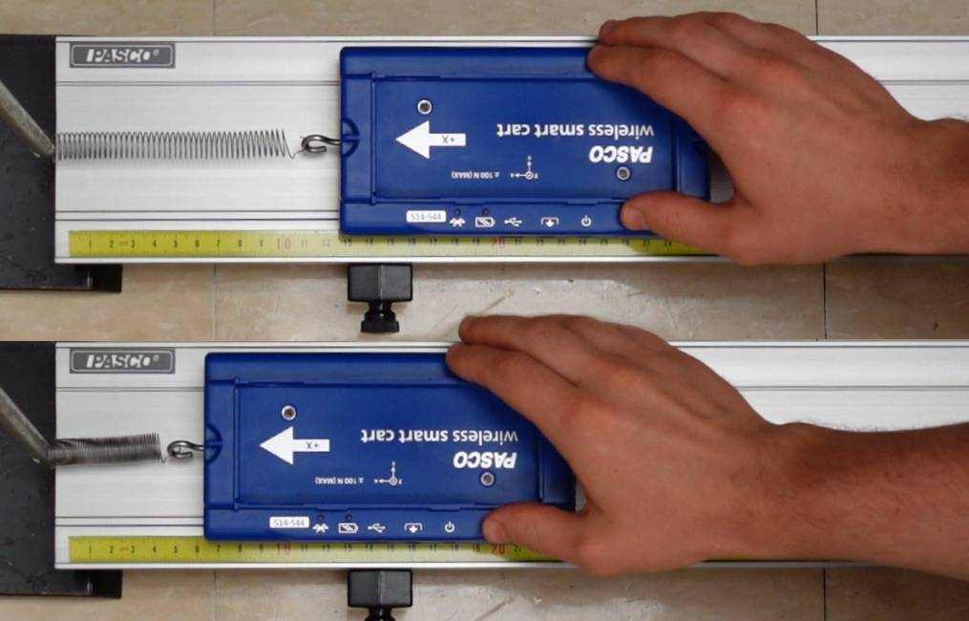
Figure 5. Using PASCO Smart Cart to determine the spring constant.

Theory
For this lab, we will be using the equations for the kinetic energy (KE) of a moving body, the simple version of potential energy (PE) (i.e., $mgh$), and the spring potential energy:
$$E_{spring}=\frac{1}{2}k{Δx}^{2} (1)$$
with $k$ being the spring constant, and $Δx$ is the distance from the spring equilibrium position.
Remember to include all relevant formulas including error propagation for each of the equations that you will use as needed using partial derivatives. Some are not shown in this manual. Write down the equation for total energy.

Analysis
We will use the method called the analysis of the residuals. A residual is a deviation from the sample mean – the plot of many residuals can tell you something about the behavior of your system in general. You are welcome to use “Lab 10 Energy Conservation -Tracker - Template.xlsx” template file provided for this analysis or make your own file. If you use the template, make sure that when you paste your data, time and vertical position columns are pasted only and in the correct positions! Otherwise, you ruin the pre-entered equations.
Using the data in the spreadsheet, calculate the kinetic energy using the $v_{y}$ data.
Formula for PE is $mgh$, where $h$ is the change in height. Because the mass oscillates around equilibrium position (that was initially set as a 0 for the $y$ axis), $y$ has both positive and negative values. The potential energy should range from 0 to some positive value as the lowest position of the mass is taken to be the 0 normally. To achieve this effect, we need to subtract the value of each amplitude from the change in height $h$ of the oscillating mass to get the correct data for the change in potential energy.
In a separate cell, enter formula “=MIN(start:end)”, where start and end cells are the whole range of the data for vertical position $y$. The value returned by this formula is the amplitude value you need to subtract from the current position y to get $h$ for the formula for PE. Thus, the formula for the potential energy in excel will look like “=$cell_for_the_mass*9.8*(data_for_the_position_y-$the_min_of_the_amplitude)”. Hint – this is already done in the template. Make sure that correct mass is entered.
Use one more column for the spring energy (eq. 1). To calculate the spring potential energy, you need to use the correct value for the elongation of the spring (using $y$ position data in the eq. 1 as it will not work). First, you need to measure the initial stretch of the spring in the Tracker. For that, you need to navigate to the very beginning of the video where the caption says “Unloaded” (also known as the “natural length of the spring”). Create the tape measure and place one end at the bottom of the spring. Move to the region of the video where the caption says “Still” and stretch the other end of the tape measure to the same part of the spring considering its elongated state. Record the distance measured (Figure 6a).
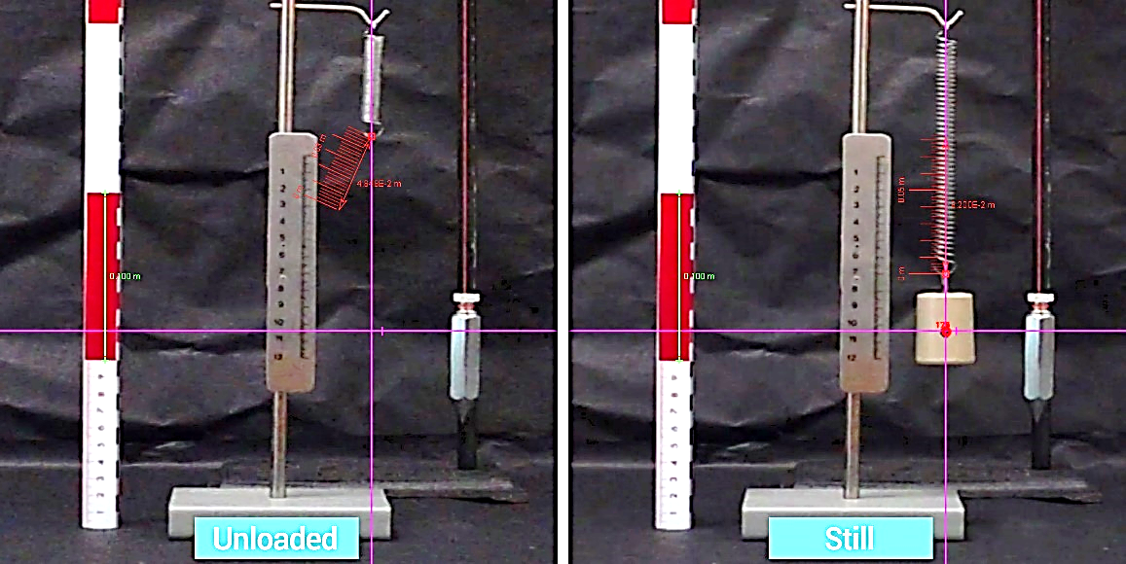
a)
Figure 6. Initial stretch of the spring, (a) value measured by the tape measure tool in the Tracker.
Now, you can use the measured distance to calculate the spring potential energy as “=0.5*$cell_for_the_k-constant_you_measured_before *(data_for_the_position_y -$stretch_of_the_spring_measured)^2”. Template does that. Enter the y stretch value correctly!
Finally, in another column “Total energy” you sum up all the energy values you have calculated: kinetic energy, gravitational potential energy and spring potential energy. Plot all the energies including the Total energy in the same graph versus time. You should have a result similar to the Figure 7.
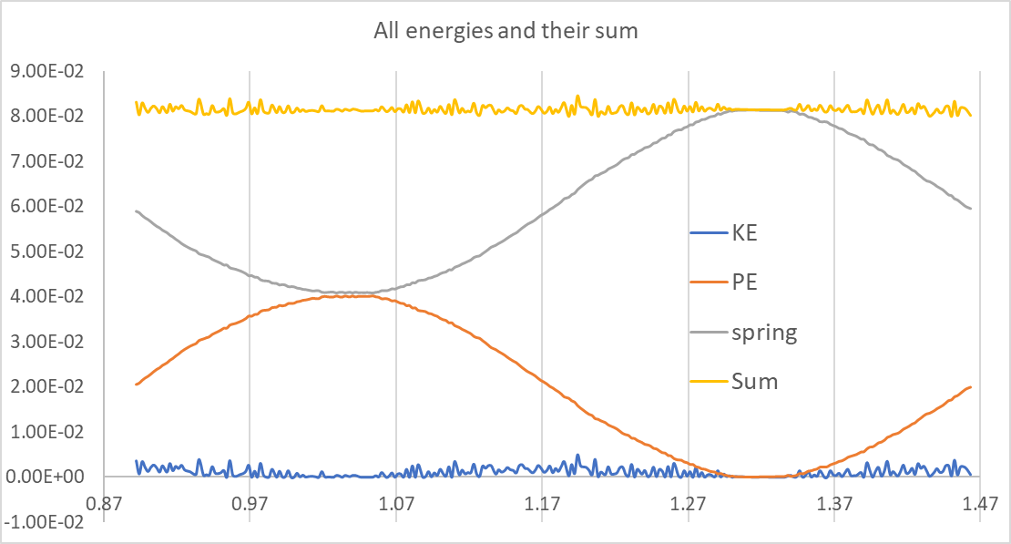
Figure 7. Total mechanical energy of the system. SPE – spring potential energy; KE – kinetic energy; PE – potential energy; Total – total mechanical energy.

Calculating residuals
Ideally, the total mechanical energy of the system should remain constant. We can check this statement if we make a plot of residuals. To do so, first find the average of all values for the total energy (the entire column), record this value in a separate cell. Then, use one more column and call it “Residuals”. For each cell, subtract from the mean the corresponding value of the Total energy. Plot residuals versus time and add trendline, do the linear regression. You should have result similar to the one in Figure 8, which shows the ‘perfect’ result. Yours will most likely differ as the line will be at some angle. This shows that something might not be right.
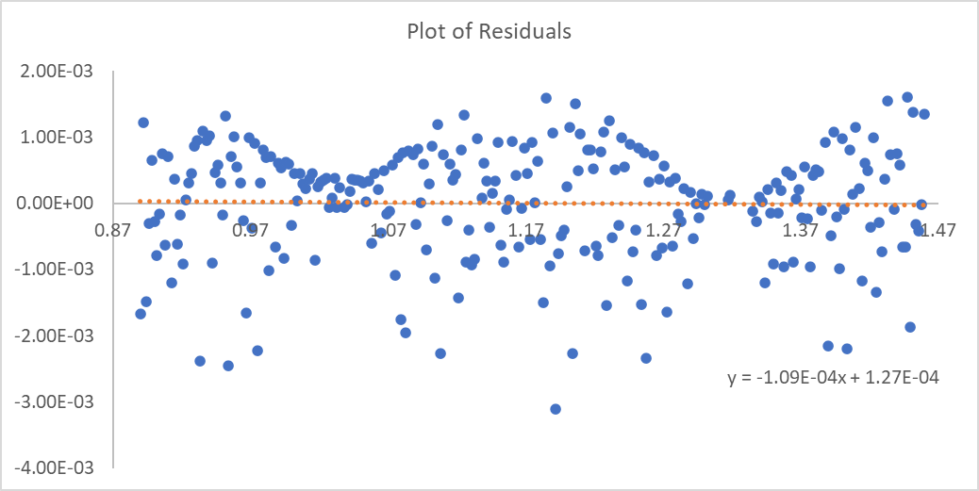
Figure 8. Total energy residuals.
If your result looks like in Figure 9, this means that something is wrong in your calculations or measurements. Think about what it could be and include it in conclusion in your lab report.
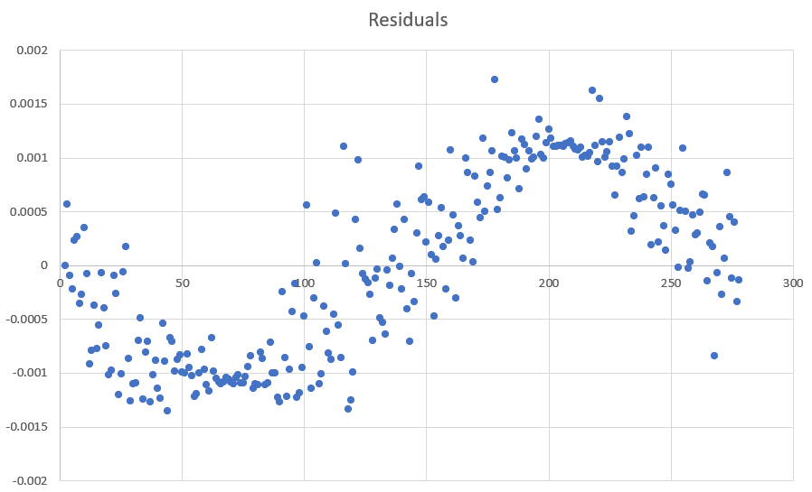
Figure 9. Wrong result for the residuals.
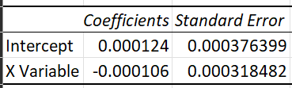
Ideally, the error on the slope and intercept in linear regression should be LARGER than the values themselves. This will indicate that the line is horizontal, and the residuals are symmetric both around the fit line and in time. Find the average of the residuals – this value should be very close to 0 for the perfect case.
Now we can use the errors for the spring constant and ‘y static’ – spring initial elongation. If your plot of residuals is not ‘nice’, or if in Figure 7 spring energy and potential energy don’t follow each other in the way shown, you can try and vary $k$ and ‘y static’ within the errors that you calculated. Example: say, $k=20.0±0.5 N/m$. Try all the values between 19.5 and 20.5 in some small steps of like 0.1 or so. See if the sum of all energies gets more horizontal and the plot of residuals starts to look ‘better’ – that is, the fit line is increasingly horizontal, and the average of the residuals gets closer to 0. Find the best values and comment on that in your report.

Conclusion
Comment on all energies plots and the total sum – is the total energy conserved? What about the plot of residuals – what does it tell you about your data… Is there a trend that shows that deviations get bigger and bigger? Is energy lost? What could be the reason? What does the stdev of residuals tell you? And the average? Any comments and improvements? Show how you find $k$, the analysis of the residuals – that is, slope and intercept + errors, average and stdev.
References – don't forget them as needed

This can be done using just the table if selecting data points in the plot doesn’t work for some reasons. Make sure that you are selecting all three - the $t$, $y$ and $v_{y}$ columns. After selecting, just move the mouse towards the $y vs t$ plot and you will see your selection highlighted in yellow.

